SAFERIDE BRAND GUIDELINES
Your Safety, Our Priority
1.Brand Colors
Primary Colors:
Color | Hex code | Swatch | Usage
Blue | #1E3A8A |  | Headers, Navigation Bar, Buttons (non-emergency)
SOS Red | #E53835 |  | SOS Buttons, Emergency Alerts, Danger Warnings

Neutral Colors:
Color | Hex code | Swatch | Usage
White | #FFFFFF |  | Text on dark background, backgrounds
Grey | #F5F6F8 |  | Secondary backgrounds, Input fields
Text Primary | #111827 |  | Body text
Text Secondary | #687280 |  | Subtext, Placeholder text, hints
Green | #43A047 |  | Body Text
Yellow | #F88C00 |  | Verified Drivers, Safe Status, Completed Rides

Color Combination Rules:
✅ Blue (#1E3A8A) + White (#FFFFFF) = Headers & Text.
✅ Red (#EA2020) + White (#FFFFFF) = Emergency alerts & SOS buttons.
❌ Never use Red (#EA2020) for non-emergency elements.
❌ Never use Blue (#1E3A8A) for emergency alerts.

2.TypoGraphy (Fonts)
Element | Style | Size | Weight
H1 | Large | 24px | Bold
H2 | Medium | 20px | Semi-Bold
H3 | Small | 16px | Semi-Bold
Body | Regular | 14px | Regular
Caption | Small | 12px | Regular
Font Family : Inter Consistent across all screens
Fonts Usage Rules:
✅ Use Inter Bold for ALL headings and titles.
✅ Use Inter Regular for ALL body text and descriptions.
✅ Use Inter Semi-Bold for ALL buttons.
❌ Never mix more than 2 fonts in one screen.
❌ Never use italic or decorative fonts.

3.Logo Usage
Primary Logo:
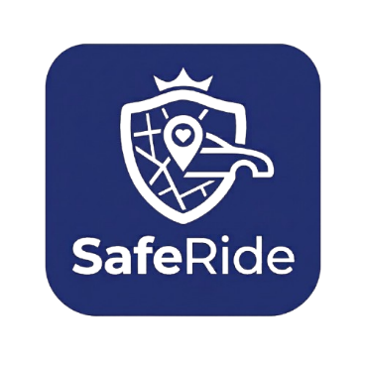
Logo Usage Rules:
✅ ALWAYS use on WHITE background | ❌ DON'T stretch or distort the logo
✅ Keep minimum 20px clear space around logo | ❌ DON'T change logo colors, add shadows, glows, or effects
✅ Use full logo (icon + text) for app and website | ❌ DON'T rotate the logo
✅ Use only icon (without text) for app icon and favicon | ❌ DON'T use on busy/noisy backgrounds

4. Tone of Voice
DO's: | DON'Ts:
✅ Use clear, simple language | ❌ Don't use slang or informal language
✅ Be empathetic and understanding | ❌ Don't be aggressive or scary
✅ Use "you" to address users directly | ❌ Don't use complex technical terms
✅ Stay calm and professional in emergencies | ❌ Don't panic users with alarmist language

5.Spacing System: 8px Grid System.
4px Micro
8px Small
16px Base
24px Medium
32px Large
48px Extra Large

6. Quick Reference Card:
📌 Colors: Main: #1E3A8A | SOS: #EA2020 | White: #FFFFFF
📌 Fonts: Headings: Inter Bold | Body: Inter Regular
📌 Logo: Use on white or blue BG | Keep 20px clear space
📌 Tone: Calm, Professional, Reassuring, Empowering
📌 Buttons: SOS buttons = Red (#EA2020) | Non-emergency = Blue (#1E3A8A)

SAFERIDE BRAND GUIDELINES | Your Safety, Our Priority

